Network Infrastructures

ATRIN BARZEGAR

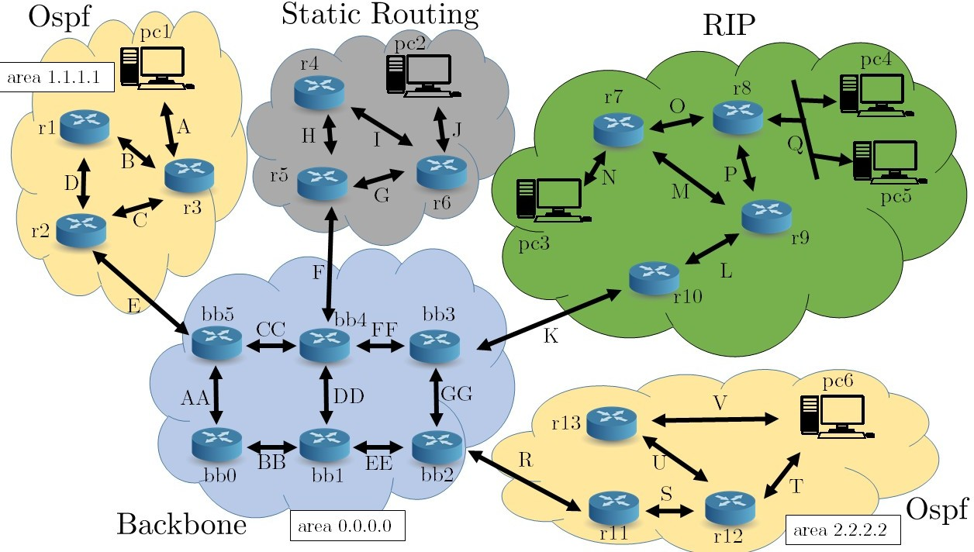

Given the following network and the following address blocks:

A = 200.0.0.0/24 B = 200.0.2.0/30 C = 200.0.3.0/30 D = 200.0.1.0/30 E = 100.0.0.0/30 F = 110.0.0.0/30 G = 210.0.1.0/30 H = 210.0.3.0/30 I = 210.0.2.0/30 J = 210.0.0.0/24 K = 120.0.0.0/30 L = 220.0.5.0/30 M = 220.0.1.0/30 N = 220.0.0.0/24

O = 220.0.2.0/30 P = 220.0.3.0/30 Q = 220.0.4.0/24 R = 130.0.0.0/30 S = 190.0.3.0/30 T = 190.0.1.0/24 U = 190.0.2.0/30 V = 190.0.0.0/24 AA = 10.0.0.0/24 BB = 10.0.1.0/24 CC = 10.0.2.0/24 DD = 10.0.3.0/24 EE = 10.0.4.0/24 FF = 10.0.5.0/24 GG = 10.0.6.0/24

1. Implement a Netkit lab such that routing is organized as in the image. Every pc must be able to ping each and all the others. In particular:
   * Yellow areas implements Dynamic Routing using OSPF;
   * Green area implements Dynamic Routing using RIP;
   * Grey area implements Static Routing;
   * Blue area represents the Backbone using OSPF;

Answer:

I put zebra folder include 3 files(deamons,ripd.conf,zebra.conf) to each folder. In each .startup file add this command(“/etc/init.d/zebra start”) to run automatically zebra in pc and routers

in each ripd.conf add “router rip ” and “redistribute connected” and for define interface(“eth”) add this command(“network ethX”)

in each deamons file active zebra=yes and ripd=yes

for implement Dynamic Routing using OSPF I put ospfd.conf in each folder of routers and define the network and area. And use stub command for define stub area.

For exapmle:

router ospf

network 200.0.0.0/16 area 1.1.1.1 area 1.1.1.1 stub

redistribute connected

for implement Static Router I define internal routing and default getway to reach to another network

for implement Backbone Using OSPF in **ASBR** Route for Rip (bb3) input ripd.conf and ospf.conf.

In ripd.conf add command “redistribute ospf”

in ospd.conf add command “redistribute rip”

for implement ASBR Route for **Static** (bb4) input ospf.conf and zebra.conf in the zebra.conf add static route for define static network

for exapmle

ip route 210.0.0.0/24 110.0.0.1

and in the ospfd.conf add “redistribute static”

1. What kind of routers are *bb3*, *bb4* and *bb5*? Add a screenshot of *bb4* Link State Database and briefly comment the fields and the results.

Answer:

bb3 and bb4 are autonomous system boundary router (ASBR) . And bb5 is area border routers (ABR).

Describe Type of ASBR and ABR routers:

Routers that act as gateways (redistribution)between OSPF and other routing protocols (IGRP, EIGRP, IS-IS, RIP, BGP, Static) or other instances of the OSPF routing process are called autonomous system boundary router (ASBR). Any router can be an ABR or an ASBR

Routers that belong to multiple areas, and connect these areas to the backbone area are called area border routers (ABR). ABRs must therefore maintain information describing the backbone areas and other attached areas.

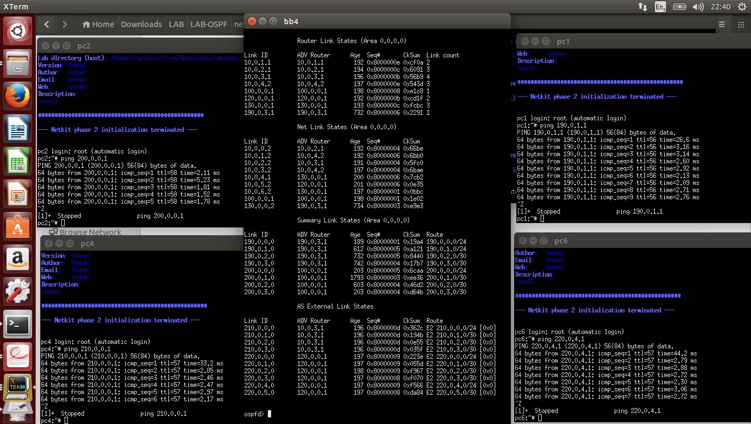

About type of link state,we have 4 type linke state:

**Router Link State:** Describe the state and cost of the routers links(interface) to the area(Intra-area)

The **link-state ID** of the type router linke state is the originating router ID and

**Link count** show how many link does it have.

Every router generates router link advertisements for each area to which it belongs. Router link advertisements describe the state of the router links to the area and are flooded only within that particular area.

**Net Link State:**Originated for multi-access segment with more than one attached router.Describe all routers attached to the specific segment.Orginated by a Designated Router(DR).

The **link-state ID** of the type Net link stateis is the IP interface address of the

DR.

DRs generate network link advertisements for multiaccess networks. Network link advertisements describe the set of routers that are attached to a particular multiaccess network. Network link advertisements are flooded in the area that contains the network.

**Summary Link State:**Originated by ABRs only.Describe network in th AS but outside of an area(Inter-area),Also describe the location of the ASBR.

The **link-state ID** of the type Summary link state is destination network number (Routers ID of stub network )and **Avg Router** is getway IP interface. An ABR takes the information that it learned in one area and describes and summarizes it for another area in the summary link advertisement. This summarization is not on by default.

**As External Link State:**Originated by an ASBR.Describe destination external the autonomous system or a default route to the outside AS.

The **link-state ID** of the type As External Link State is the external network

number.Avg Router is getway IP interface for ASBR

Autonomous system external link advertisements, which are generated by ASBRs, describe routes to destinations that are external to the autonomous system. They get flooded everywhere, except into special areas.

1. Set the cost of links CC and FF to 90 and traceroute pc2 and pc6 from pc1 (pc1-

>pc2,

pc1->pc6). Add a screenshot of the traceroutes and comment.

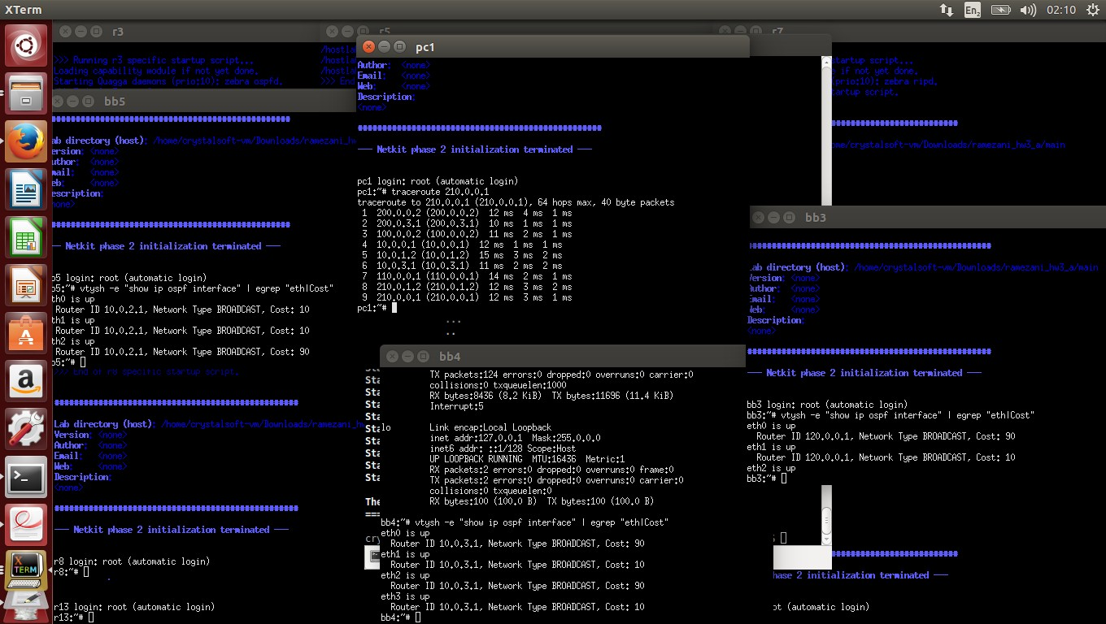

Answer:

I use “interface eth2” and “ospf cost 90” in ospfd.conf for define cost

After add cost for CC and FF ,OSPF routing try to change database and find Short path so the route of pc1 to pc2 is change and go from bb5->bb0->bb1->bb4

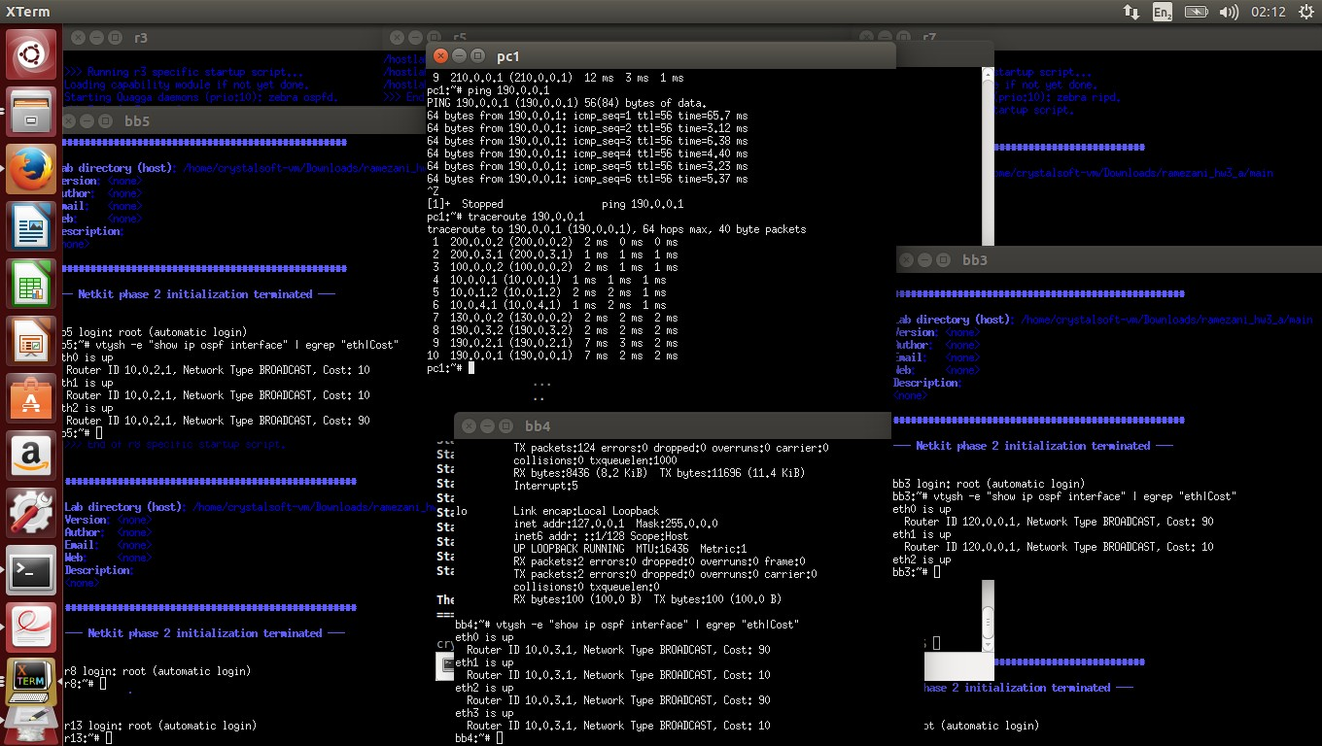

Answer:

pc1 to pc2 is use the short and best path so go on bb5->bb0->bb1->bb2

1. **EXTRA POINTS**: What is STP? Does it have any conceptual similarity with OSPF?

Imagine now that the given topology is made of bridges (or switches) instead of routers. Find a Spanning Tree rooted at bb0.

Answer:

STP was created to prevent [bridge](http://searchsecurity.techtarget.com/definition/bridge) loops by allowing only one path between network [switches](http://searchtelecom.techtarget.com/definition/switch) or [ports](http://searchnetworking.techtarget.com/definition/port). When a network segment goes down, an alternate path is chosen and this process can cause unacceptable delays in a data center network.

Yes if we use bridges coceptual can be similar